**Problems**

**1) Draw a diagram of the following code (picture at the end of the code). Filename should be  pointer1.jpg**

int  main() {  
 int a, b = {2}, *p, *q;  
 p = &a;  
 p = p + 1;  
 q = &b;  
 q = q - b;  
 a = &b - q;  
 return 0;  
}

**2) Filename should be pointer2.jpg**

 int  main() {

    int a[16], b[16], *p, *q, *r, *s, x = 10, y = 15, i;  
    p = a + 5;  
    q = &b[0] + 3;  
    r = a + 7;  
    s = q + 2;  
    x = r - p - (p - a)  + 2;  
    y = q - b  + x;  
    p = p + x;  
    p[-2] = 20;  
    q[2 + y - x] = 30;  
    *(p + x + 9) = x;  
    *(s + (s - q)) = y;

     return 0;}

**3. Filename should be pointer3.jpg**

typedef struct slot {  
    int value;  
    char arr[10];  
    char *cp;  
    struct slot *sp;  
}slot;  
int main() {  
    slot a, b, *p, *q;  
    a.sp = &b;  
    p = &b;  
    q = &a;  
    p->sp = &a;  
    p->cp = &(q->arr[5]);  
    b.cp = &(b.arr[1]);  
    p->value = b.cp - p->cp;  
    q->value = 10;  
    strcpy(b.arr, "hello");      
    return 0;  
}

**4. Filename should be  pointer4.jpg**

struct test {  
        char data;  
        struct test *one;  
        struct test *two;  
};  
typedef struct test test;  
int main() {  
        test *p, *q, *r;  
        int i, j;  
        /* assume that all mallocs succeed */  
        p = (test *)malloc(sizeof(test));  
        r = (test *)malloc(sizeof(test));  
        q = p;  
        for(i = 0; i < 3; i++) {  
                p->two = r;  
                r->two = p;  
                p->one = (test *)malloc(sizeof(test));  
                p = p->one;  
        }  
        p->one = p->two = q;  
        q->one = q->two = r;  
}

**5. Filename should be pointer5.jpg**

**Submission Procedure:**

int main() {  
        typedef struct node {  
                char *name;  
                struct node *nptr;  
                int *iarray;  
                int ilen;  
        }node;  
        node *p, *q, a;  
        char name[8], number[8];  
        int i;  
  
        a.name = (char *)malloc(5);   
        strcpy(a.name, "coep");  
        i = 2;  
        p = &a;  
        while(i < 10) {  
                /* assume all mallocs succeed */  
                p->nptr = (node *)malloc(sizeof(node));  
                strcpy(name, "coep");                     
                sprintf(number, "%d", i);                 
                strcat(name, number);  
                p->nptr->name = (char *)malloc(strlen(name) + 1);  
                strcpy(p->nptr->name, name);  
                p->nptr->iarray = (int *)malloc(sizeof(int) * i);  
                p->ilen = i;  
                q = p;  
                p = p->nptr;      
                i = i << 1;  
        }  
        q->nptr = &a;  
        return 0;  
}  
**Part-2**  
**1) Filename: headernodecircular.c**   
Write a C program which reads multiple items of data of type given below from the user, and creates the following type of diagram.   
typedef struct data { char name; struct data *p;}data;   
Note: this is a diagram after reading only two data elements. ('x' and 'y').   
The first structure in the diagram has a name 'a' and does not store any data.   
If there is not data read, then a.p points to a.   
You should write code which creates such a diagram for an unspecified number of data elements.  
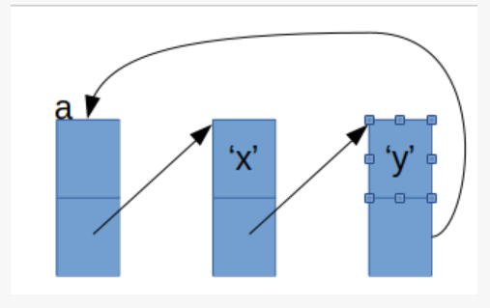

**2) Filename: pointercircular.c**This problem is similar to problem-1 above. The diagram below is after reading three data elements ('w', 'x' and 'y')  
and the pointer 'p' always points to the first element read. If there is no DATA read, P is NULL. The last element  
always points to first data element.

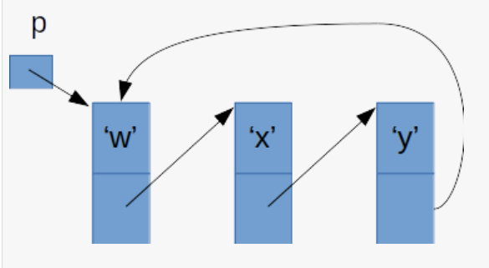

You should write code which creates such a diagram for an unspecified number of data elements.

Collect all files in one folder. Name the folder as follows

rollno_batch_branch_pointers1

Now, compress the folder and create a file called

rollno_batch_branch_pointers1.tar.gz

Submit this file.

You can create the .tar.gz file, in any one of the two ways:

1) Use the graphical file browser. Right click on the folder and click compress. Then select appropriate options

2)Use command line. Use the following command, in the parent folder of the folder with your files.

> tar cvzf  folder_name.tar.gz  folder_name